PSG COLLEGE OF TECHNOLOGY, COIMBATORE – 641 004
Department of Applied Mathematics and Computational Sciences
MSc SOFTWARE SYSTEMS – Semester IV
20XW48 – Web Designing Lab
PROBLEM SHEET 6 – CSS3 Layouts & Positioning
-SWETHA MURALIDHARAN
-20PW35

- Make a layout template that contains a header and two paragraphs. Use float to line up the two paragraphs as columns side by side. Give the header and two paragraphs a border and/or a background color so you can see where they are.

<html>
<head>
<style>
header
{
padding:30px;
background-color:black;
color:white;
text-align:center;
}
p
{
background-color:#666;
color:white;
border:2px solid white;
text-align:center;

}
.A
{
float:left;
width:50%;

}
.B
{
float:right;
width:50%;
}
</style>
</head>
<body>
<header>
<h2> HEADER </h2>
</header>
<div class="A">
<p> PARAGRAPH-1 </p>
</div>
<div class="B">
<p> PARAGRAPH-2 </p>
</div>
</body>
</html>


- Design a web page with four paragraphs. Apply a different border style and background to each paragraph using CSS code.

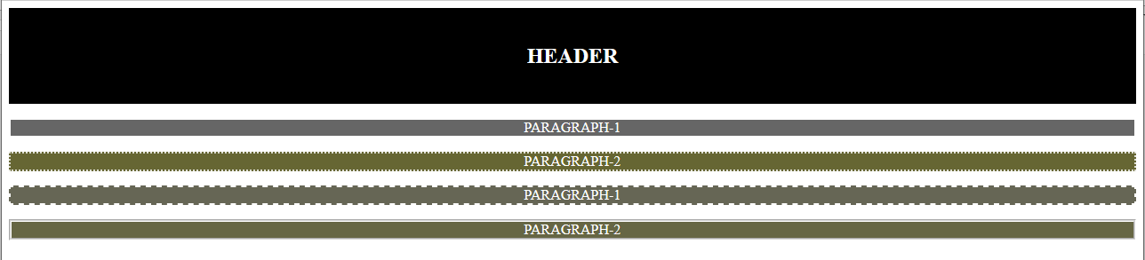
<html>
<head>
<style>
header
{
padding:20px;
background-color:black;
color:white;
text-align:center;
}
.A
{
background-color:#666;
color:white;
border:2px solid white;
text-align:center;
}
.B
{
background-color:#663;
color:white;
border:2px dotted white;
text-align:center;
}
.C
{
background-color:#665;
color:white;
border:2px dashed white;
text-align:center;
}
.D
{
background-color:#664;
color:white;
border:3px groove white;
text-align:center;
}

</style>
</head>
<body>
<header>
<h2> HEADER </h2>
</header>
<div>
<p class="A"> PARAGRAPH-1 </p>
</div>
<div>
<p class="B" > PARAGRAPH-2 </p>
</div>
<div>
<p class="C" > PARAGRAPH-1 </p>
</div>
<div>
<p class="D"> PARAGRAPH-2 </p>
</div>
</body>
</html>

- Write a CSS rule to design a web page layout as shown below:
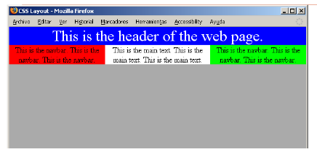
<html>
<head>
<style>
header
{
padding:20px;
background-color:blue;
color:white;
text-align:center;
}
p
{
text-align:center;

}

.A
{
background-color:red;
width:35%;
float:left;
}
.B
{
background-color:white;
width:30%;
float:left;
}

.C
{
background-color:green;
width:35%;
float:left;
}
</style>
</head>
<body>
<header>
<h2> This is the header of the web page </h2>
</header>
<div class="A">
<p> This is the navbar. This is the <br>navbar.This is the navbar. </p>
</div>
<div class="B">
<p> This is the main text. This is the <br>main text.This is the main text. </p>
</div>
<div class="C">
<p> This is the navbar. This is the <br>navbar.This is the navbar. </p>
</div>
</body>
</html>
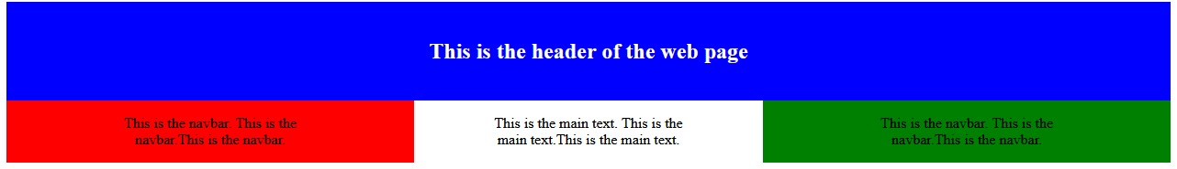

- Use CSS code to create the following page: The page contains the following text – “Now paragraphs can have a border of their own”. The text should be positioned 100 pixels from the top and 40% from the right margin of the browser. The font is “Times Roman” in italics, the letter size 30 pixels and the color ABCDEF(h). The text is enclosed on all sides by a grooved border with the colors CC99CC, 99CCCC, CCCC99, C9C9C9 starting from the right border anti-clockwise respectively. The corresponding border thickness are 5 pt, 10 px, 2 cm, 1 in. The letter spacing should be 2 pixels and there should be a horizontal line through it.

<html>
<head>
<style>
p
{
padding-top:100px;
margin-right:40%;
font-style:italic;
font-family:Times New Roman;
font-size:30px;
color:#ABCDEF;
border-right:5px groove #CC99CC;
border-top:10px groove #99CCCC;
border-left:2cm groove #CCCC99;
border-bottom:1in groove #C9C9C9;
letter-spacing:2px;
text-decoration:underline;
}
</style>
</head>
<body>
<p> "Now paragraphs can have a border of their own"</p>
</body>
</html>
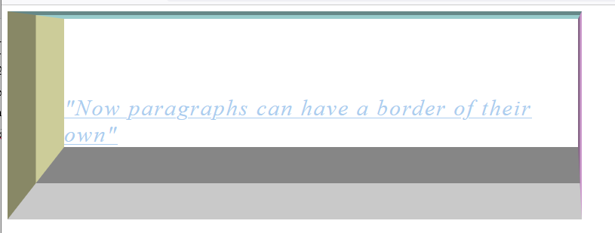

- Create three div elements, each with a width and height of 100px. On the first element, create slightly rounded corners using a border of 3px black and border-radius of 10px. On the second element, use a border of 3px black and increase the border-radius to 50px. On the third, use a border of 3px black and increase the border-radius to 100px. Make the background-color of each element a different color of your choosing. Inside each element, display the value of the border-radius in bold text.

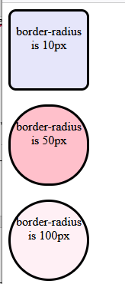
<html>
<head>
<style>
div
{
width:100px;
height:100px;
}
.first
{
border:3px solid black;
border-radius:10px;
background-color:lavender;
}
.second
{
border:3px solid black;
border-radius:50px;
background-color:pink;
}
.third
{
border:3px solid black;
border-radius:100px;
background-color:lavenderblush;
}
p
{
font-style:bold;
text-align:center;
}
</style>
</head>
<body>
<div class="first">
<p> border-radius is 10px </p>
</div>
<br>
<div class="second">
<p> border-radius is 50px </p>
</div>
<br>
<div class="third">
<p> border-radius is 100px </p>
</div>
</body>
</html>

- Write the CSS rule to design page layout as shown below:

- Create three div elements of varying colors, each with a width and height of 200px. On the first box, add a dimgrey box-shadow with a horizontal offset of 15px, a vertical offset of 15px and a blur radius of 20px. On the second box, add a dimgrey box-shadow with a horizontal offset of -15px, a vertical offset of -15px and a blur radius of 30px. On the third box, add a dimgrey box-shadow with a horizontal offset of 15px, a vertical offset of 15px and a blur radius of 10px.

<html>
<head>
<style>
.first
{
width:200px;
height:200px;
box-shadow:15px 15px 20px dimgrey;
}
.second
{
width:200px;
height:200px;
box-shadow:-15px -15px 30px dimgrey;
}
.third
{
width:200px;
height:200px;
box-shadow:15px 15px 10px dimgrey;
}
</style>
</head>
<body>
<div class="first">
</div>
<br>
<div class="second">
</div>
<br>
<div class="third">
</div>
</body>
</html>


- Write the CSS code to reproduce the following table using CSS positioning instead of <table> tag.h
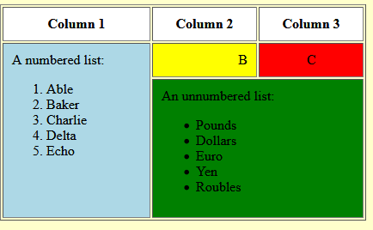

<html>
<body>
<div style="border:1px solid black ; background-color:lightyellow;width:50% ; height:60%;">
<div style="border:1px solid black;">
<div style="border:1px solid black; background-color:white; width:35%; height:10%;float:left;text-align:center;"> <p> Column 1 </p> </div>
<div style="border:1px solid black; background-color:white; width:33%; height:10%; float:left;text-align:center;"> <p> Column 2 </p> </div>
<div style="border:1px solid black; background-color:white; width:31%; height:10%; float:left;text-align:center;"> <p> Column 3 </p> </div>
</div>
<div style="border:1px solid black; width:35%; background-color:skyblue;float:left; height:50%;">
<p> A numbered list
<ol type="1">
<li> Able </li>
<li> Baker </li>
<li> Charlie </li>
<li> Delta </li>
<li> Echo </li>
</ol>
</p>
</div>
<div style="border:1px solid black;float:left;width:64%;">
<div style="border:1px solid black;background-color:yellow;text-align:right;float:left;width:48%;"> <p> A </p> </div>
<div style="border:1px solid black;background-color:red;text-align:center;float:left; width:51%;"> <p> B </p> </div>
</div>
<div style="border:1px solid black;background-color:green;width:64%; float:left;">
<p> An unnumbered list
<ul>
<li> Pounds </li>
<li> Dollars </li>
<li> Euro </li>
<li> Yen</li>
<li> Roubles </li>
</ul>
</p>
</div>
</div>
</body>
</html>

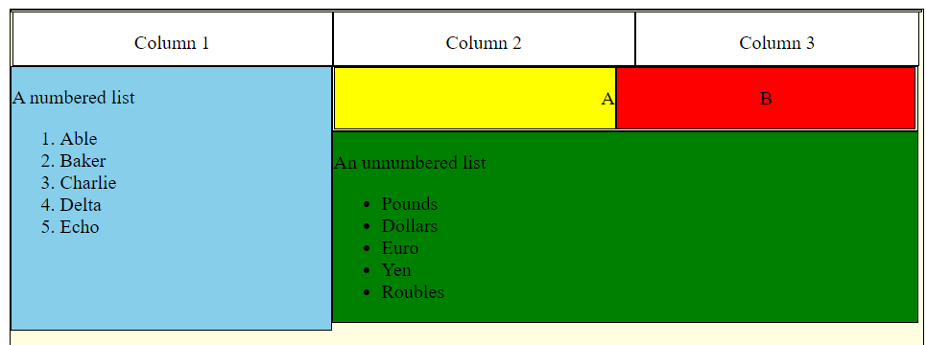

- Write the CSS code to design a drop-down menu as shown below.
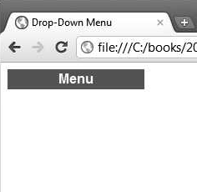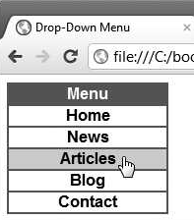

- Write the CSS rule to display the content in a web page with two-column and three-column layout as shown below
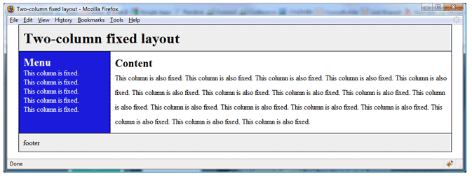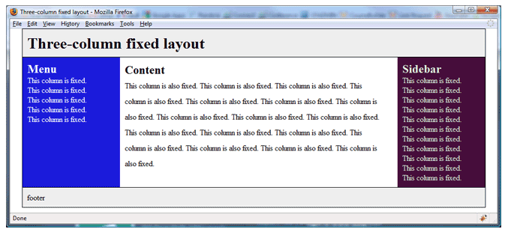
<html>
<head>
<style>
.row
{
display: grid;
grid-template-columns: 300px 300px;
display:flex;
}
.col1
{
padding:16px;
height: 250px;
font-size:20px;
background-color:blue;
color:white;
}
.col2
{
padding:16px;
height: 250px;
}

</style>
</head>
<body>
<header style="background-color:lightgrey; height:15%;font-size:50px;font-style:bold;">
<p> Two-column fixed layout </p>
</header>
<div class="row" >
<div class="col1">
<h2 style="font-style:25px;"> Menu </h2>
<p> This column is fixed <br>
This column is fixed <br>This column is fixed <br>This column is fixed <br>This column is fixed <br>This column is fixed <br>
</p>
</div>
<div class="col2">
<h2>Content</h2>
<p> This column is fixed This column is fixed This column is fixed This column is fixed This column is fixed This column is fixed This column is fixed This column is fixed This column is fixed <br>
This column is fixed This column is fixed This column is fixed This column is fixed This column is fixed This column is fixed This column is fixed This column is fixed This column is fixed <br>
This column is fixed This column is fixed This column is fixed This column is fixed This column is fixed This column is fixed This column is fixed This column is fixed This column is fixed <br>
This column is fixed This column is fixed This column is fixed This column is fixed This column is fixed This column is fixed This column is fixed This column is fixed This column is fixed <br>
This column is fixed This column is fixed This column is fixed This column is fixed This column is fixed This column is fixed This column is fixed This column is fixed This column is fixed <br>
This column is fixed This column is fixed This column is fixed This column is fixed This column is fixed This column is fixed This column is fixed This column is fixed This column is fixed <br>
</p>
</div>
</div>
<footer style="background-color:lightgrey; height:10%;font-size:30px;display:flex;">
<p> footer </p>
</footer>

</body>
</html>
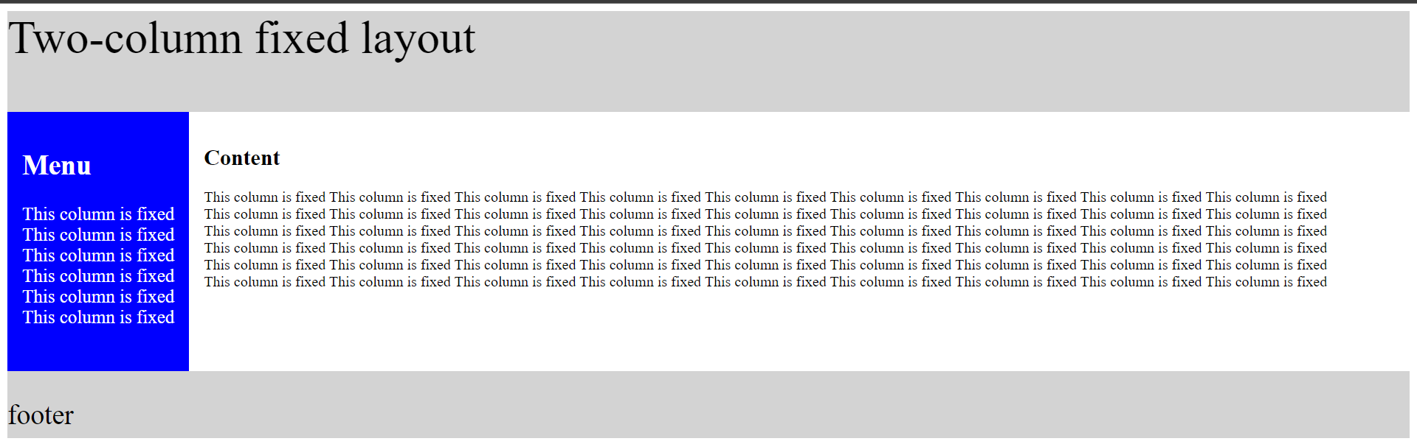

<html>
<head>
<style>
.row
{
display:flex;
}
.col1
{
padding:16px;
height: 250px;
font-size:20px;
background-color:blue;
color:white;
}
.col2
{
padding:16px;
height: 250px;
}

.col3
{
padding:16px;
height: 250px;
width:150px;
background-color:darkmagenta;
color:white;
}
</style>
</head>
<body>
<header style="background-color:lightgrey; height:15%;font-size:50px;font-style:bold;">
<p> Three-column fixed layout </p>
</header>
<div class="row" >
<div class="col1">
<h2 style="font-style:25px;"> Menu </h2>
<p> This column is fixed <br>
This column is fixed <br>This column is fixed <br>This column is fixed <br>
</p>
</div>
<div class="col2">
<h2>Content</h2>
<p> This column is fixed This column is fixed This column is fixed This column is fixed This column is fixed This column is fixed This column is fixed This column is fixed This column is fixed <br>
This column is fixed This column is fixed This column is fixed This column is fixed This column is fixed This column is fixed This column is fixed This column is fixed This column is fixed <br>
This column is fixed This column is fixed This column is fixed This column is fixed This column is fixed This column is fixed This column is fixed This column is fixed This column is fixed <br>
This column is fixed This column is fixed This column is fixed This column is fixed This column is fixed This column is fixed This column is fixed This column is fixed This column is fixed <br>
This column is fixed This column is fixed This column is fixed This column is fixed This column is fixed This column is fixed This column is fixed This column is fixed This column is fixed <br>
</p>
</div>
<div class="col3">
<h2>Sidebar</h2>
<p> This column is fixed <br>
This column is fixed <br>
This column is fixed<br>
This column is fixed <br>
This column is fixed<br>
This column is fixed<br>
This column is fixed<br>
This column is fixed<br>
</p>
</div>
</div>
<footer style="background-color:lightgrey; height:10%;font-size:30px;display:flex;">
<p> footer </p>
</footer>

</body>
</html>
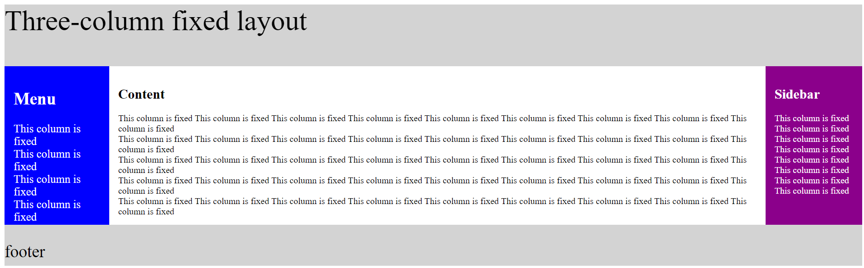

- Write the CSS code for the below output.
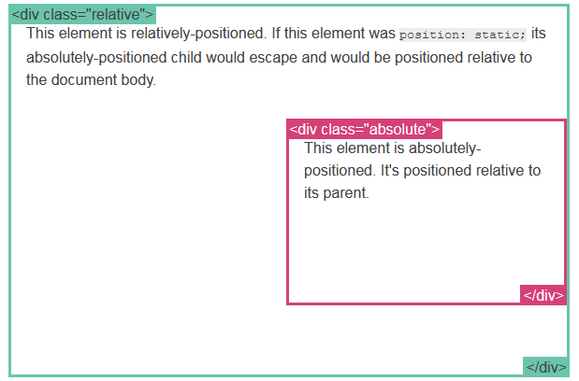

- Write a CSS code to design a web page as shown below using layout and positioning rules:
